RIDE WITH ME
Technical Overview

Prepared By: Felix Ingabire (TL)
Prepared For: Car rental booking project
Date Submitted: 11 July 2014

Version | 0.1
Last Update | 13 July 2014
Creation Date | 11 July 2014

Definitions and Acronyms
Term | Definition
TO | Technical Overview
TL | Technical Lead
PM | Project Manager
ST | Software Tester
SA | System Administrator
SE | Software Engineer
IDE | Integrated Development Environment
JSON | JavaScript Object Notation) is a lightweight data-interchange format.
DBMS | Data Base Management System
Eclipse EE | Eclipse Enterprise Edition
SQL | Standard Query Language
JDK | Java Development Kit
HTML | Hyper Text Markup Language
CSS | Cascading Style Sheets
HTTP | Hyper Text Transfer Protocol

TECHNICAL OVERVIEW

1. Introduction

1.1 Document Purpose.
The purpose of this document is to describe all the tools and technology that will be used in our project. This document attempts to mention the technologies that will be used in a clear and concise manner.

1.2 Audience.
- Project Manager
- System Administrator
- Software Engineers
- Software Testers

1.3 Project Background.
The purpose of this project is to build a System that makes it easy to book a ride. We have a concept called ‘Ride-Sharing’ in which, anyone who owns a car, a valid driver’s license and passes a medical checkup, can volunteer their vehicle for hire as a taxi to the general public. The application makes it easy for drivers and prospective passengers to find each other and agree a fee between themselves. Our system will have two beautifully designed and easy to use applications, one for drivers and one for passengers.

The System is composed of four different Modules.
- Two Android Applications, One to be used by drivers and one to be used by prospective passengers.
- One Website. This is for administrative purposes. The main goal of the website will be to register drivers.
- A Server to manage the database and to send and receive requests and responses from the two applications and the website.

2.0 Development Tools

- Eclipse EE: will be used for developing the back-end server.
- MySQL and Heidi SQL: will be used to handle our databases and all DBMS related technology.
- Jdk 1.6: Android development only supports Java version 6 and above.
- Apache Ant: Apache Ant is a Java library and command-line tool whose mission is to drive processes described in build files as targets and extension points dependent upon each other. The main known usage of Ant is the build of Java applications. Ant supplies a number of built-in tasks allowing to compile, assemble, test and run Java applications.
- Apache Tomcat: This is the tool we’ll use to run our server side technology
- Android studio: is going to be used to build the two Application; Driver application and User application. We use this to design the UI and logic of the two different clients.

3.0 Development language

Our Development languages consist of:
- The Java programming language in which we will perform nearly all our programming work.
- Our two mobile applications use the Android Framework.
- Http (requests/responses) to communicate with the server.
- HTML, CSS and JavaScript to develop the administrative website
- JSON to transfer information between our applications and the Server.

4.0 Hardware requirements for development

- Linux-based server
- Phones or tablets with internet capability which run Android 4.0.0 or above (for testing purposes)
- Computers with enough resources to properly execute all the development tools specified in section 2.0
- Network with Internet Access.

6. Physical Architecture
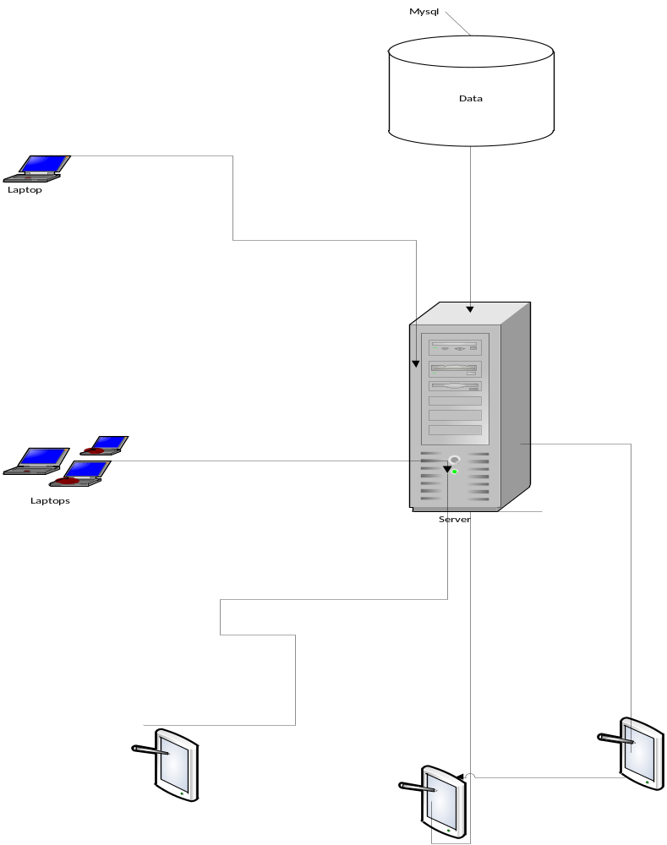
Admin
Driver
User
Web-based Service
User

